Out of the box functionalities for TeamSD

Make diagrams look prettier…

Use Analytics

Customize your encyclopedia with NFCs

System Architect for Team Solution Design
Authors: Adam Jeffries
Claire De Bie

Table of Contents
Detailed functionalities: 1
Make diagrams look prettier… 1
Use Analytics 1
Customize your encyclopedia with NFCs 1
Table of Contents 1
1. Basic User Formatting Capabilities 3
1.1. Hierarchy Diagrams 3
1.2. Format Settings/Options 4
1.3. Changing Line Styles 5
1.4. Symbol Align 6
1.5. Route Lines 9
1.6. Display Mode 10
1.7. Moving Symbol Name 11
2. Analytic Builder Wizard 13
3. Managing Non Functional Characteristics with the Userprops Editor 16
3.1. Requirements 16
3.1.1. Flexibility in creating your own set of NFCs 16
3.1.2. Structure in the definition of NFCs 16
3.1.3. Reporting 16
3.1.4. Initial Setting 16
3.2. Proposed Solution 16

Basic User Formatting Capabilities

Hierarchy Diagrams

TeamSD Example: Current Organisation – Position (Org Unit) Chart

System Architect handles diagrams of type Hierarchy differently as it automatically arranges Child node symbols. The following describes how to arrange node symbols differently or hide children trees from the diagram.
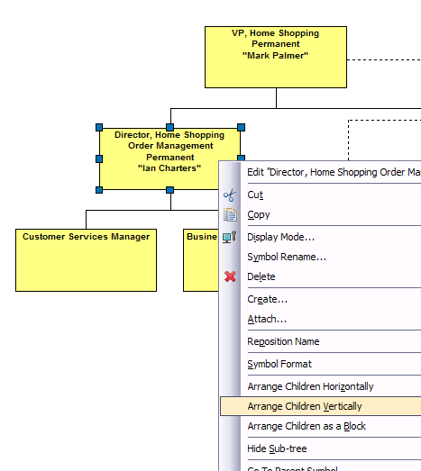 | - Right Click on parent node symbol.  - Select either Arrange Children Horizontally/Vertically/as a Block.  - Select “Hide Sub-Tree” to hide children.
Figure 1: Children Displayed Horizontally

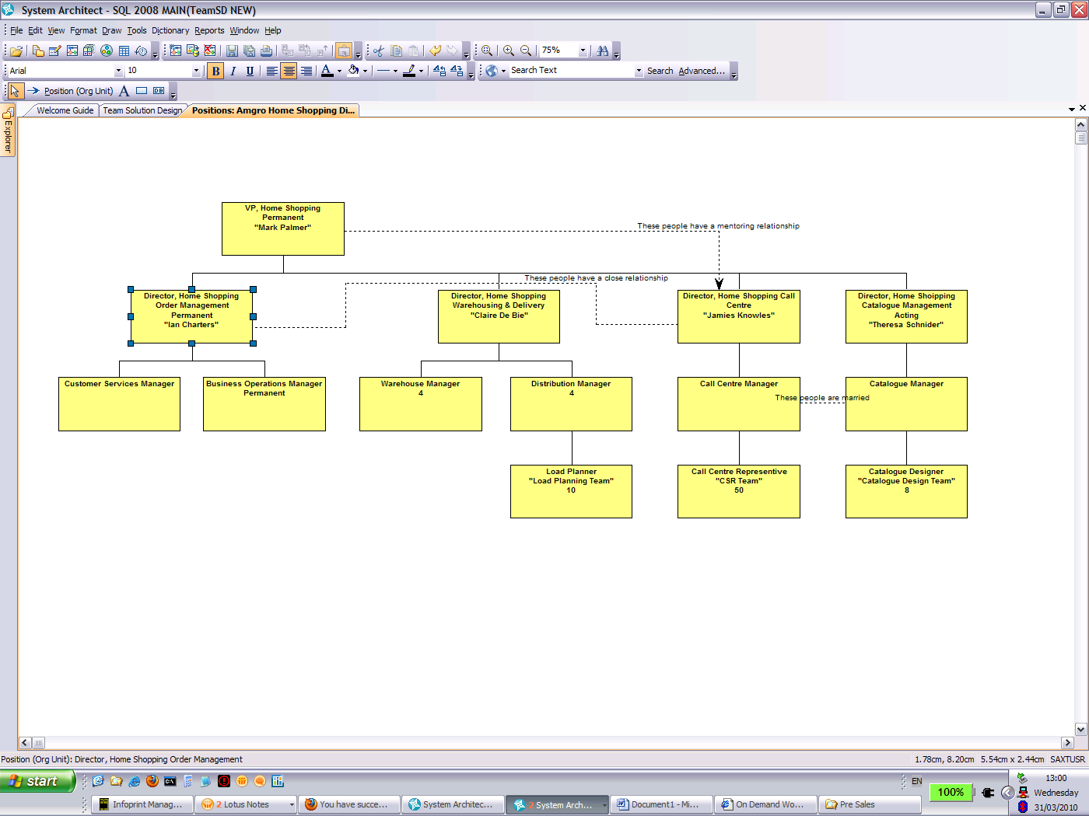 | 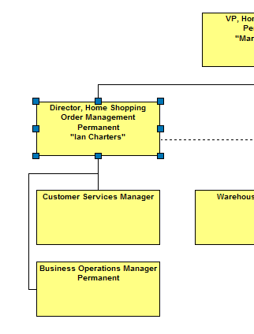
Figure 2 Children Displayed as a Block | Figure 3 Children Displayed Vertically

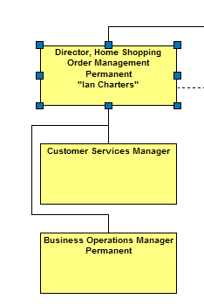 | 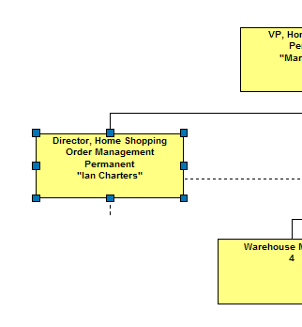
Figure 4 : Children Hidden Sub-Tree

Format Settings/Options
System Architect provides a number of options for changing the format of a particular symbol.
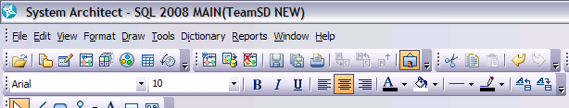
Format Toolbar
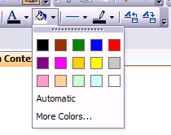 | 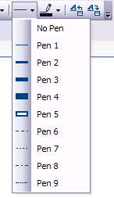
Example options provided by Format toolbar
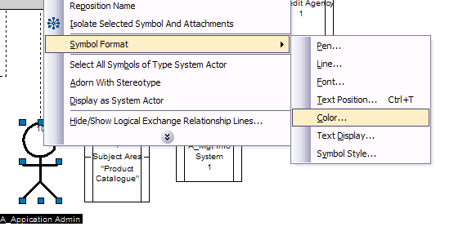
Accessing Format options using floating menu
 |  | 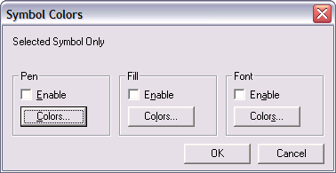
 |  | Example options to change colours

Changing Line Styles

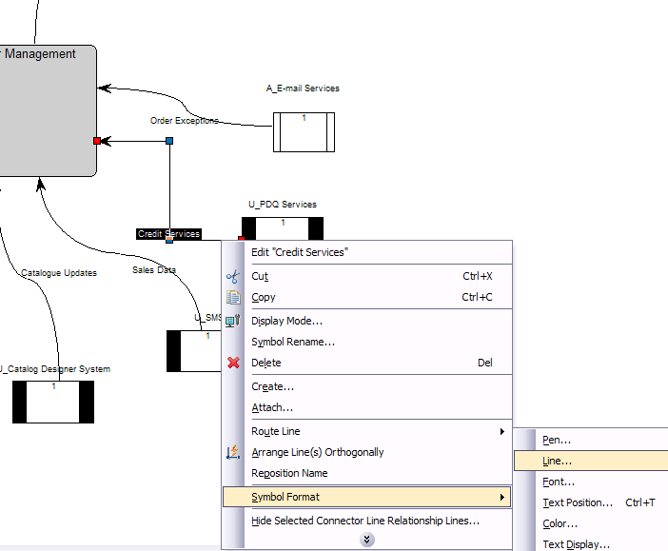 | - Right Click on the line symbol and select Symbol Format → Line
Accessing line format from floating menu to control line style

- Select the desired line style.  N.B. Curvature affects the curve of an orthogonal right angle  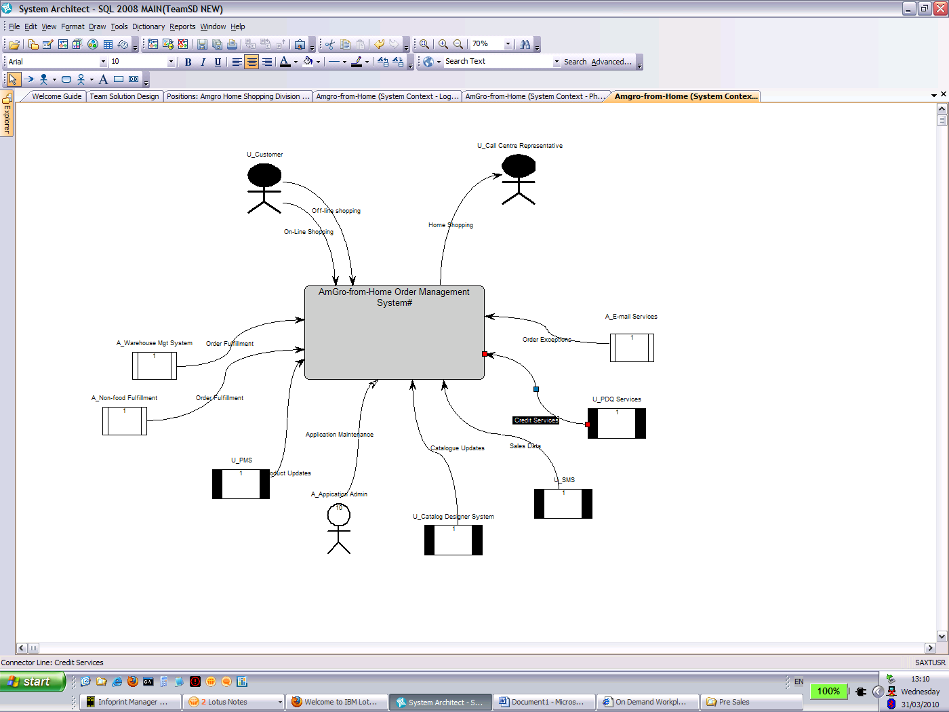 | 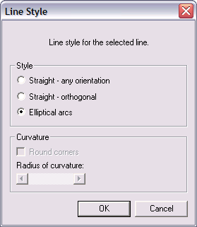
 | Options to change line style

Symbol Align

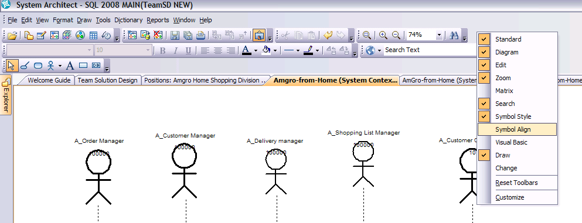
Adding Symbol Align Toolbar

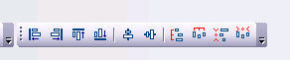 | - You can add the Symbol Align toolbar by Right Click on main toolbar and select “Symbol Align”  - Alternatively you can select symbols on the current diagram and the FORMAT → ALIGN menu is enabled.
Symbol Align Toolbar

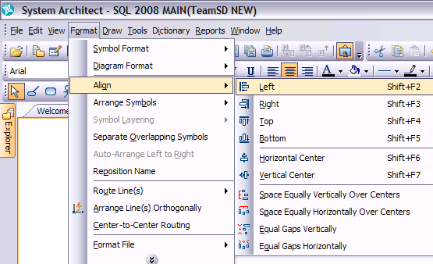
Access Symbol Align Toolbar from Menu

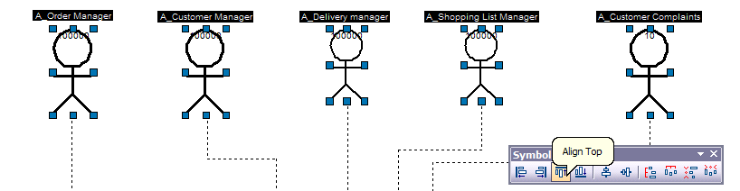
Align Symbols by top of last selected symbol

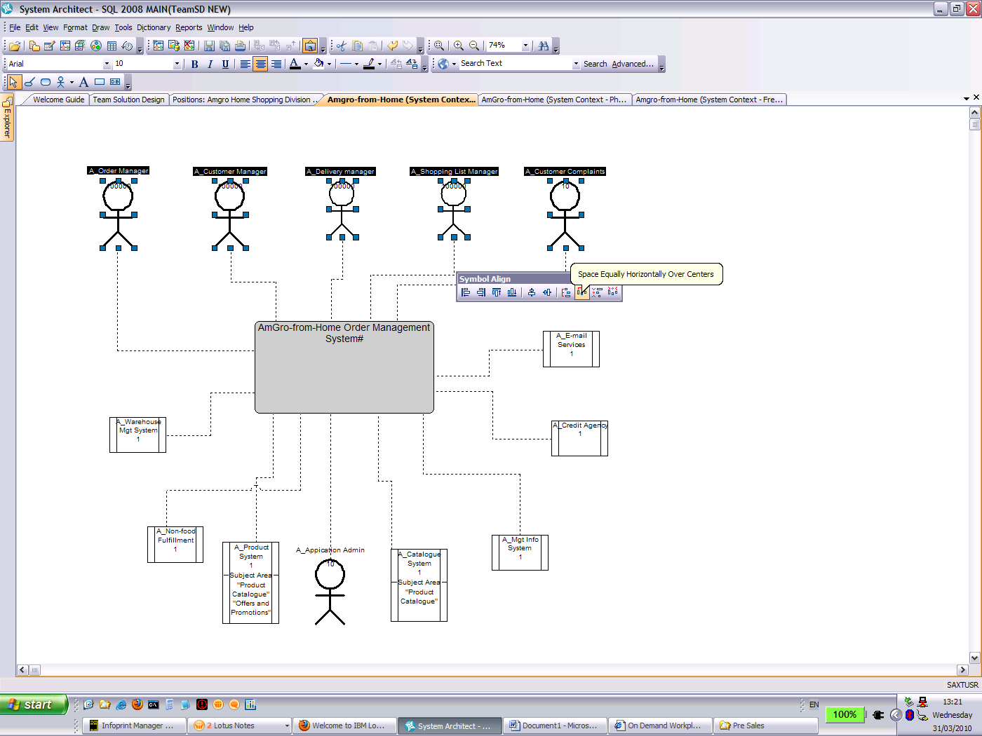
Align Symbols with equal spaces over center
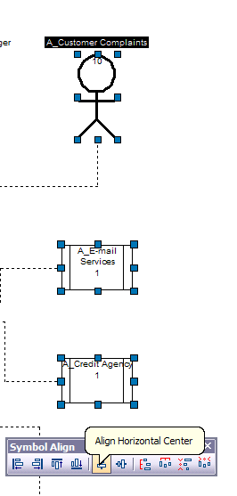 | - The screenshots show different align functions which can be combined to arrange your diagram node symbols  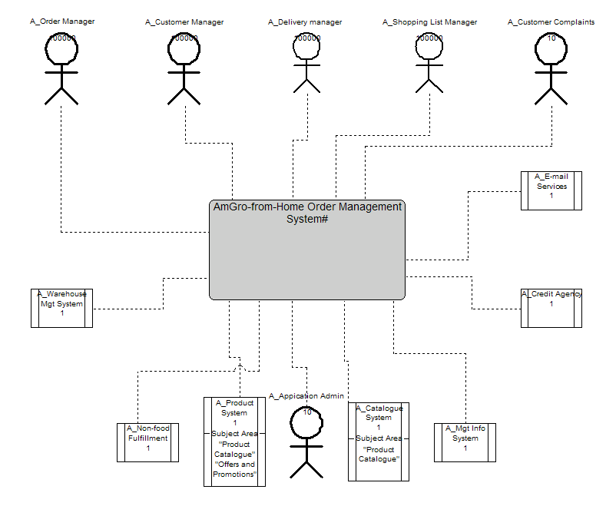
Align Symbols by horizontal center of last selected symbol
 | Diagram with Aligned Node Symbols

Route Lines
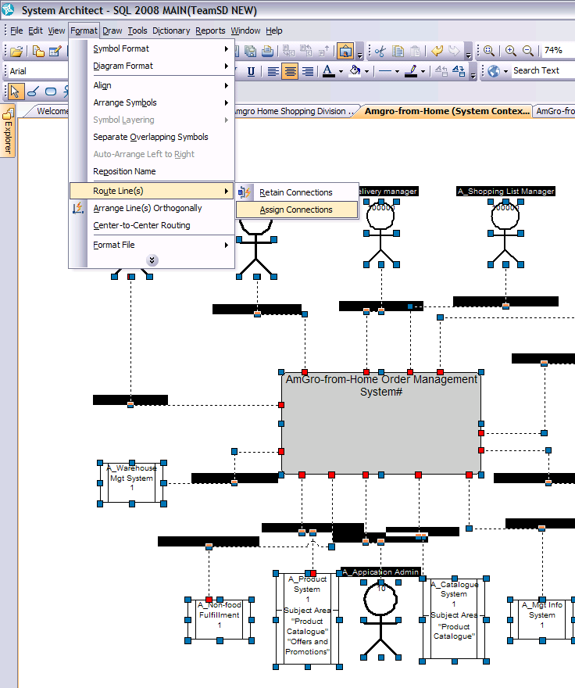
Diagram with Aligned Node Symbols
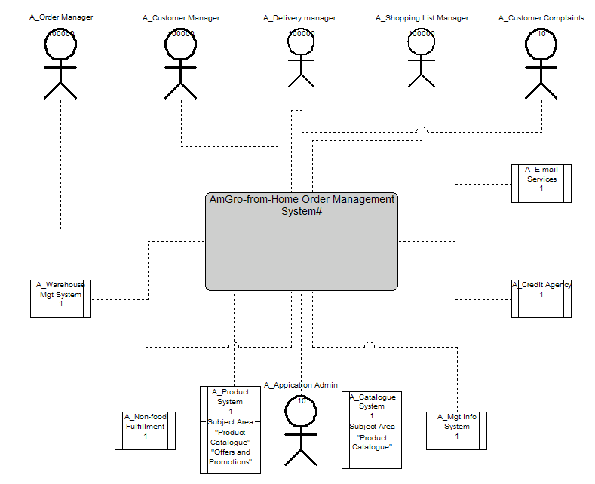
Diagram with Route Lines Assigned to Line Symbols
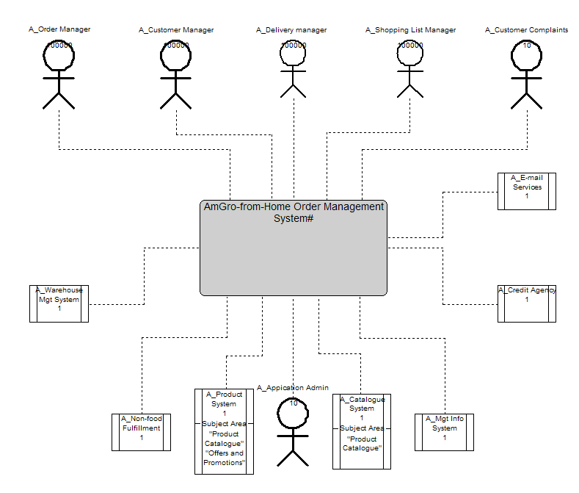
Diagram with Tidy Line Symbols

Display Mode

The display mode dialog can be accessed by right clicking on the symbol you want to edit its display properties and selecting DISPLAY MODE

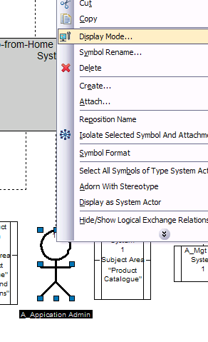 | 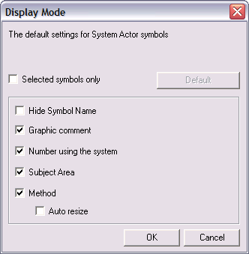
Access Display Mode from floating menu | Display Mode dialog

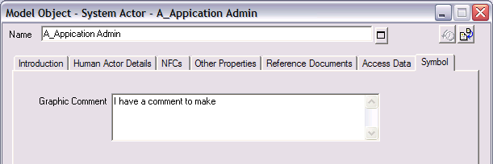
Editing definition to add symbol comment
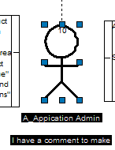
Viewing symbol comment on diagram

Moving Symbol Name
- Simply select the symbol name and use the mouse to move name to desired position on diagram | 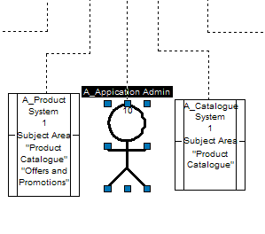
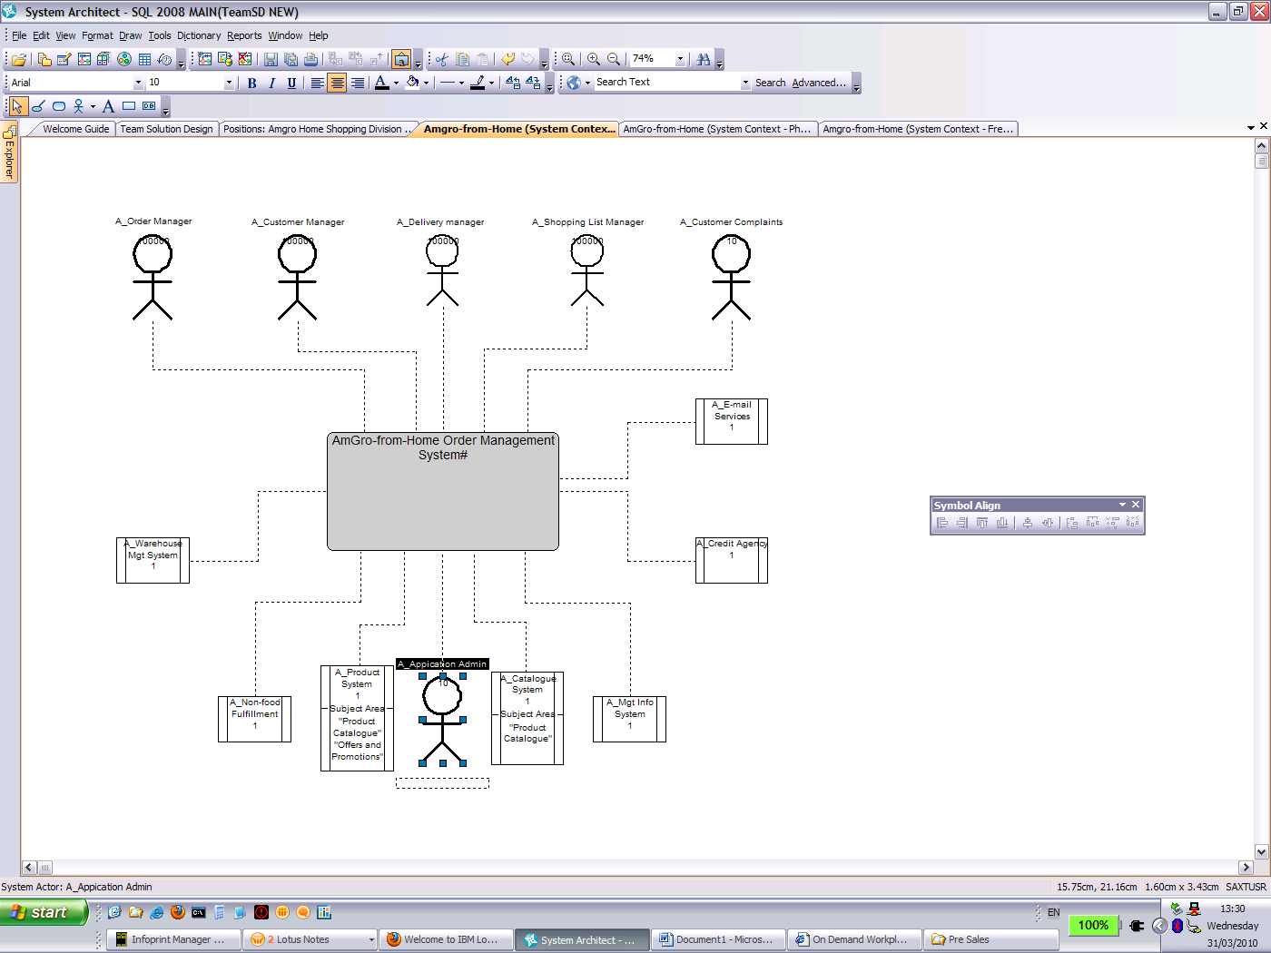 | 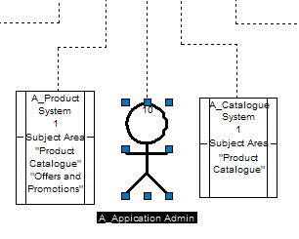

Analytic Builder Wizard
Initially, the purpose of the Heatmap Manager and its Analytics is to analyse and understand EA information. You can use the Heatmap Manager on any diagram and define your own Analytics easily through this feature.
In the case of TeamSD, we offer this capability as a solution to identify more easily a type of definition type on a diagram. Example: a Logical Component is defined as Enterprise, Application or Technical in SA for teamSD. However we may need to precise its type (Software, Database, File or user defined values), and to identify this specific type quickly on a diagram.

The SA helpfiles describe in details how to use the Analytic Builder Wizard and to create your own Analytics for this purpose. We are here focused on the steps to define and show subtypes for Logical Component definitions, this being feasible for any definition with a stereotypes list property and a usable symbol.

For the example, we’ve added a list of subtypes to the Logical Component Definition. User Defined values can be added to the list. | 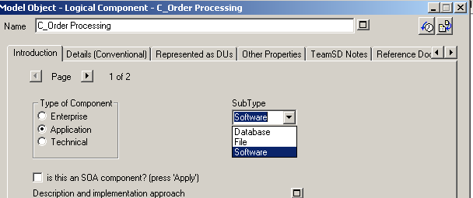
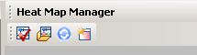 | The example is taken on the Component Model – Logical Structure View.  - Open the Heatmap Manager – Menu View> Heatmap Manager.  - Click on Analytic Builder Wizard (4th icon in the Heatmal Manager dialog)
Create New Analytic
Create a new Analytic (this will be one item of your keys)  Give it a relevant name – here we are looking for the Logical Component of subtype database – then click “Next” | 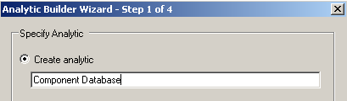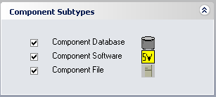
Create a new Analytic report
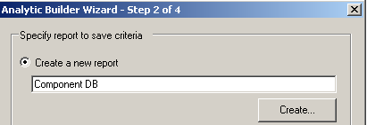 | Create a new Analytic report – this is the query run by the Analytic. Give it a similar name as the Analytic itself (just an idea to keep it tidy) and press “Create”
Create your query – here we want all Logical Component which Subtype property is set to “Database”.  Then press OK and hit the Next button on dialog again. | 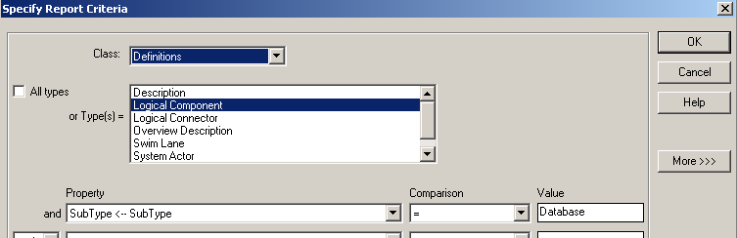
Then you need to define if you want to colour the symbol or display a small icon next to the main symbol to identify the type.
1 – Colour the symbol | 2- Attach an icon
Choose the “Colour” option  Select “Select” button and the colour you want to use.  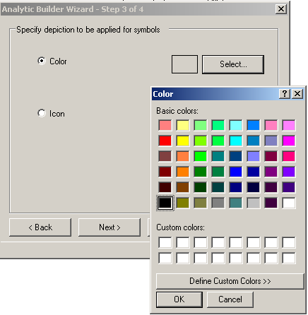  Note: this option doesn’t work for symbol using wmf files.  Then press OK and Next. | Choose the “Icon” option  Select Browse to select the image – either a bmp or a wmf file. The list which appears is the list of files loaded in the encyclopedia.  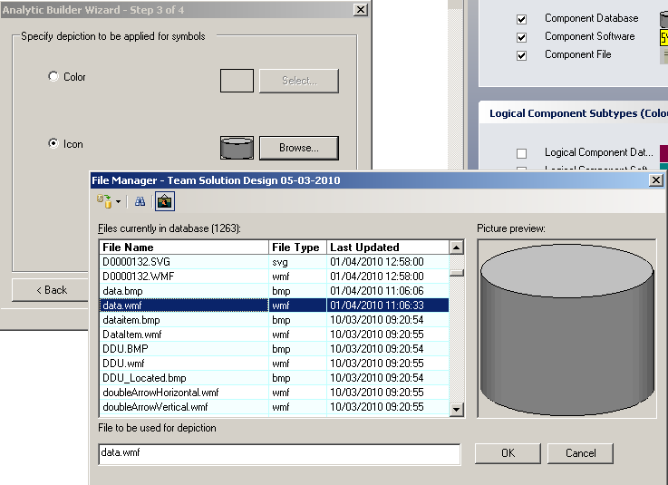  Import a new file: first icon on top left corner.  Select and show a picture: second icon.  Display an overview of the image: third icon.  Select the file you want to attach to the property value. Then press OK and Next.
Then create Analytic Collection and confirm Summary:
Create a new Analytic Collection. This will be the name of the Analytics Set.  Press Next | 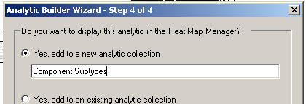
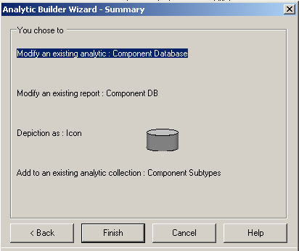 | Confirm the summary pressing “Finish”. The Heatmap Manager then displays the new key.
Add another Analytic to the Collection:
Follow the same steps as describes above:
- Create New Analytic
- Create a New Analytic Report – choosing here another value of Subtype.
- Colour the Symbol or Attach an icon to the Analytic
- Then Choose an Analytic Collection
Choose an Analytic Collection → Component Subtypes  Then press “Next” and Finish on Summary. | 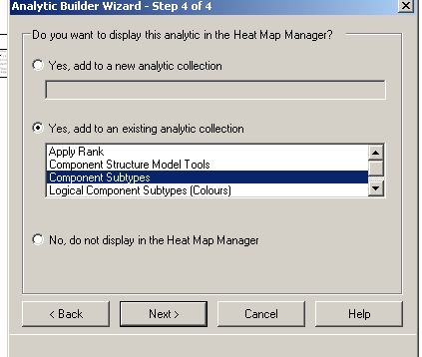
Note: as the list of values of the Subtypes property is flexible, you can type your own value there and attach an icon to it through an Analytic. This feature can be used as a way of showing a user defined value on a diagram through an icon.

Managing Non Functional Characteristics with the Userprops Editor

Requirements

3.1.1. Flexibility in creating your own set of NFCs
- Users need to be able to define their own set of NFCs, which can vary from one definition type to another.
- They also need to be able to define their own set of values for a property (eg: high, medium, low...)
- The process to achieve this has to be simple and easy. No direct usrprops updates preferable.
- Once that is set, the user can set the NFC values for each definition.

3.1.2. Structure in the definition of NFCs
- When creating a new NFC property for a definition type (example: I want to create a Security NFC for the Network definition type), 2 symmetrical lists has to be created: (to continue with our example) Required Security and Supported Security will be 2 NFC properties of the Network definition.
- A definition type can have up to 6 Required NFC properties, so up to 6 Supported NFCs.
- Each NFC property can have up to 5 values to choose from.

3.1.3. Reporting
- NFCs values will be used for reporting and SA is required to give “warning” according to the values and properties. Eg: if a connection with low required security is crossing a high required security border, there is a conflict and it must be flagged.
- NFCs values can also be used for calculation. Eg: 10 connections with bandwidth “Mbps” and Border these connections cross also with bandwidth “Mbps”, there is a conflict and it must be flagged.
- Reporting facilities: the reporting and calculation above must be reported/ flagged with colours on diagrams, customized reports (with conflicts highlighted)

3.1.4. Initial Setting
- System Architect would have a pre-defined set or NFC properties for a selection of definition types to start with.

Proposed Solution
The approach we are using here is the ability to update the Metamodel – create your own set of properties – using the Metamodel Editor and the pre-defined set of properties configured for TeamSD in System Architect.

The Metamodel Editor uses specific definition types to describe the model elements and their properties.  A set of pre-defined definitions called “User …” are loaded in your TeamSD encyclopedia and gives a structured environment for you to define your set of Non Functional Characteristics. |  |  |  | 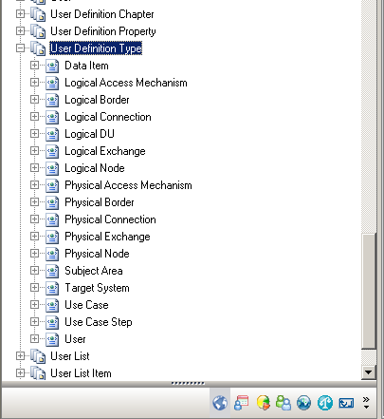
Metamodel Editor “Tools”
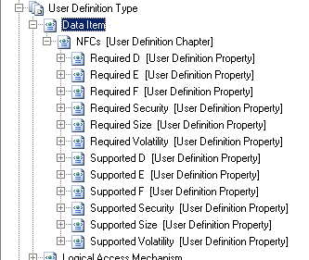 |  |  |  | User Definition Type: definition types elected to have NFCs applied. Eg: Data Item.  User Definition Chapter: Every NFC property is defined on a tab called “NFCs” – the only exception being Logical DU. Eg: see NFCs in picture.  User Definition Property: available properties per definition type. Eg: Required Currency, Required Volatility, supported E…
Each property is associated with a list of possible values the NFC can be set to. These lists can be seen and defined as shown:  User List: Name of the list of values. This list is re-usable in different properties.  User List Item: Possible value the NFC can be set to. Eg: High, Medium, Low |  |  |  | 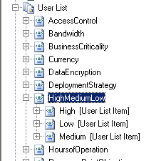
Each User Definition Type definition has a set of 12 properties – 6 required and 6 supported NFCs. Some of these properties are already set as a default NFC. Eg “Required Currency”, “Supported Currency”. Some others are available for you to customize as you define your model elements. In the paragraphs below, we walk through the steps to define our own NFCs.
Add a new NFC: Create a Currency NFC for Data Item.
The Data Item originally has the set of NFCs shown here: 3 defined NFCs [Size, Security, Volatility] and 3 available NFCs [D, E, F] each with a Required and Supported symmetrical properties.  This is how it appears in the definition -→ |  |  | 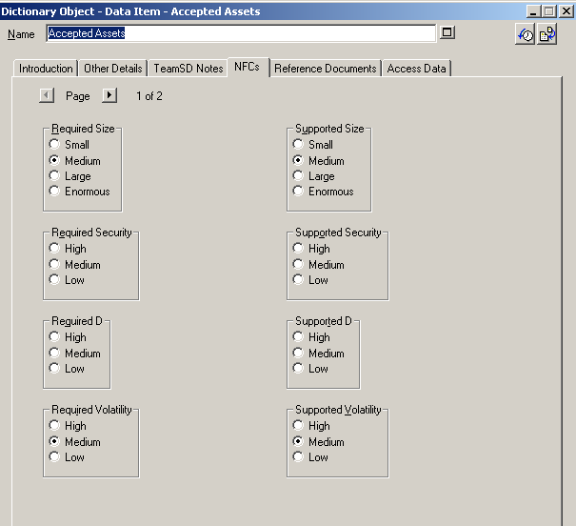
<---This is how it is configured via the metamodel editor.

We’d like to define a Currency NFC for Data Item, ie rename an un-used property to Currency.

Here we’ll use D to define the Currency property. We’ll rename the chosen Required and Supported Properties and set their set of values.
1. Open “Required D [Data Item]” [User Definition Property]  2. Rename to “Required Currency” |  |  | 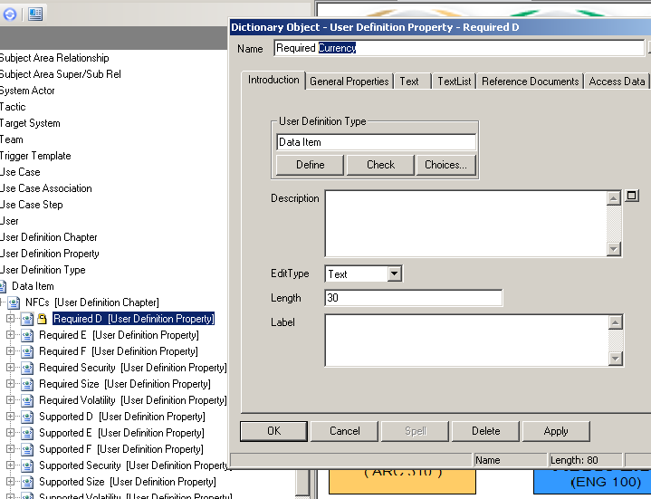
3. Set the list of values, associated with the property.
a. Re-use existing: Pre-defined lists of values exist in the encyclopedia. You can reuse them easily in user-defined properties.
Run the report to see existing list of value:  - Menu Reports> Report Generator Reports  - Select “Non Functional Characteristics – Available List”  - Press “Generate”. The available lists and associated values are displayed in a grid. |  | 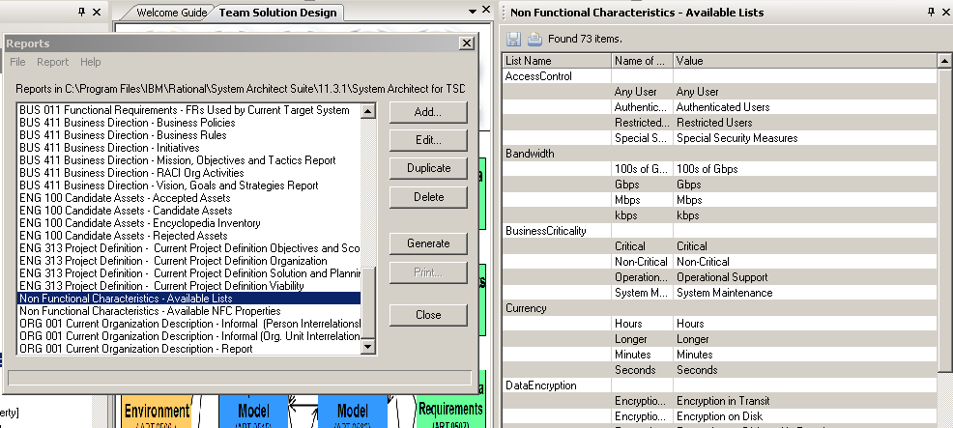
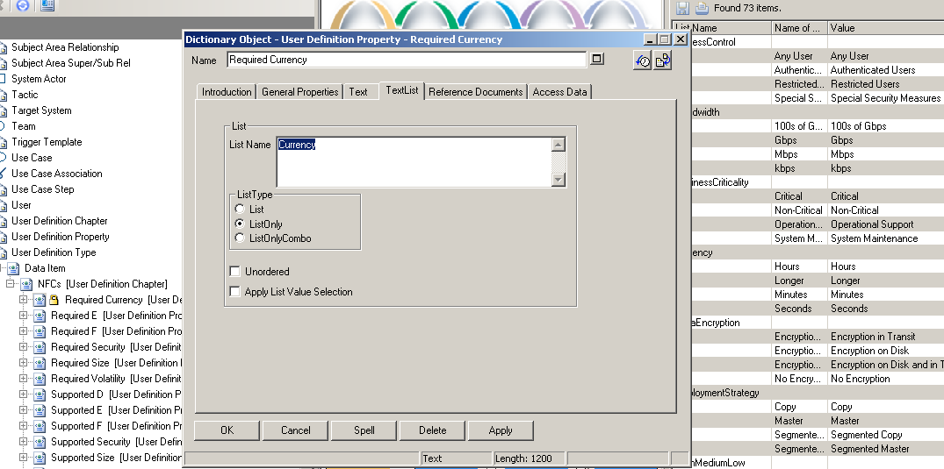 |  | Reuse the “List Name” value to set the property list of values.  - In renamed “Required Currency” definition, go to the “Text List” tab.  - List Name property, type the name of the list to reuse: Currency [values will be Hours, Seconds, Minutes, Longer]
b. Create list of values: You can also create your own set of values using the User List definition type
- Right click on “User List” and select “New” in the floating menu.  - Give the new list of values a relevant name.  - In the “Values” property, enter the different possible values of the list.  - For each possible value, click on Define to create the definition and fill the “Value” property with the possible value.  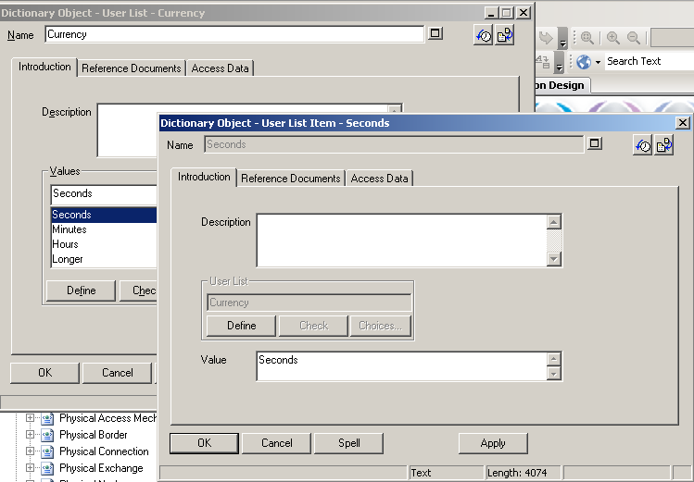 |  |  | 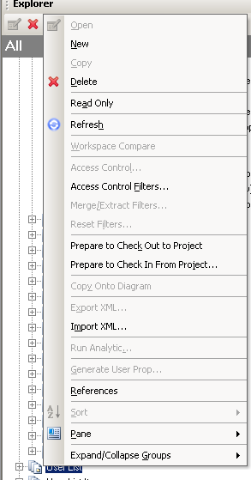
4. Repeat same steps for “Supported D”  a. Open “Supported D” [Data Item] definition.  b. Rename “Supported D” to “Supported Currency”  c. Update the name of the list of values in use for this property: “Currency”. |  |  | 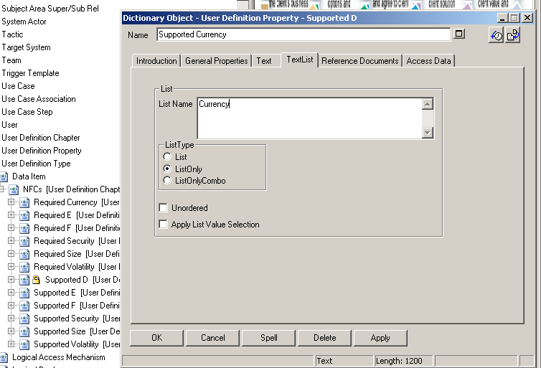
5. Generate and load the metamodel file holding the customization.
This Usrprops.txt file holds the customization. This file is generated from the User Props File definition type called “NFC Test”.  The NFC Test definition is pre-defined to export in a text file the Required and Supported NFCs for each pre-defined definition types.  Note: If you’ve only updated existing definition, you only have to generate. If you’ve created new Lists, add these lists as follow:  - On the objects tab, “Select Objects in the sequence to be presented” property, Press the Choices button.  - Drag and drop the new lists from the dialog into the property window at the beginning of the list.  - Click OK. | 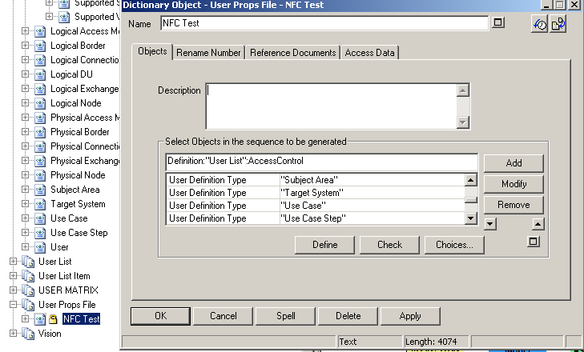
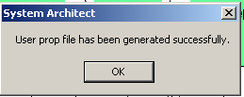 | Generate the Usrprops file:  - Select the definition “NFC Test” [User Props File]  - Right click on this definition and select “Generate User Prop…” in the floating menu.  - Save the file in a known folder – can be in System Architect for TSD folder.  - A message is displayed to confirm the good generation.
Authorise the encyclopedia to be re-open: for the changes to be taken into account, the encyclopedia need re-opening. Click ok to the message displayed. | 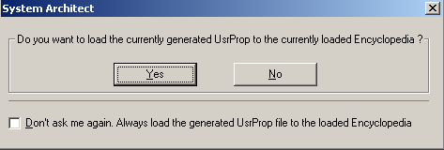
Note: regarding data exchange:
- The usrprops file containing user defined customization is included in encyclopedia backups. When a backup is shared, no information is lost.
- If data is exchanged via xml or csv, the same environment needs to be set up before import. In these cases, only the usrprops file needs to be exchanged and loaded in the encyclopedia in use.

